**Data Visualization and Analysis Project- By Saurav Dey**

**Super Store Sales Dashboard**

**1.Which product categories have the highest total sales in the "Superstore" dataset?**

Used a horizontal bar chart with product categories on the y-axis and total sales on the x-axis. This chart type effectively compares sales across different categories.

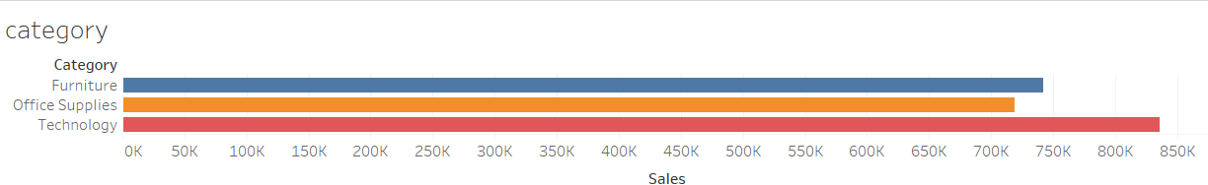

**2.How do the monthly sales amounts change over the course of a year?**

Used a line chart with months on the x-axis and total sales on the y-axis. This chart type shows the trend of sales over time.

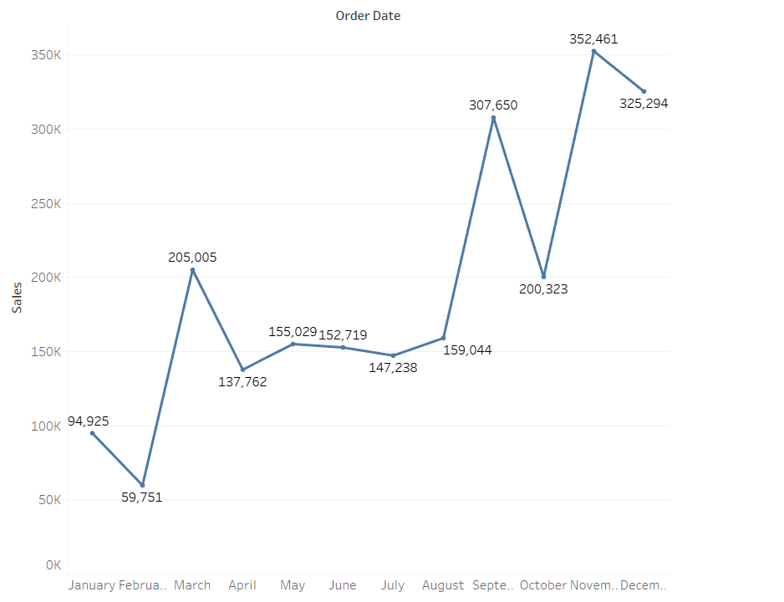

**3.How is the total sales amount distributed among different product categories?**

Used a pie chart or a stacked bar chart with product categories as segments. This visualization will show the proportion of sales contributed by each category.

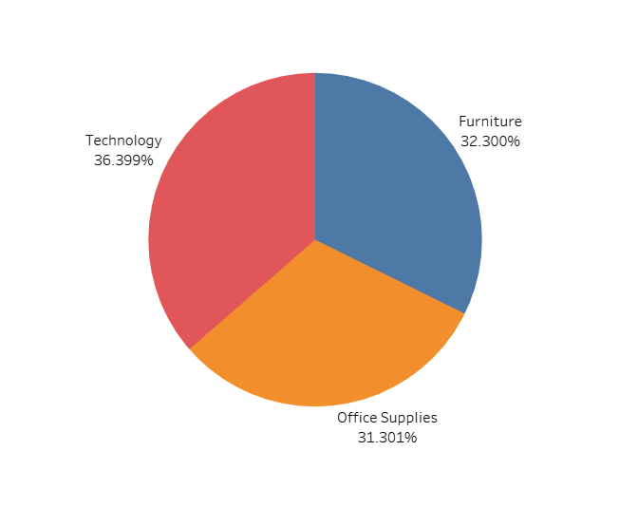

**4.Can we analyze the sales performance of individual customers over time?**

Use a line chart with time on the x-axis and sales on the y-axis. Each line represents the sales trend of an individual customer.

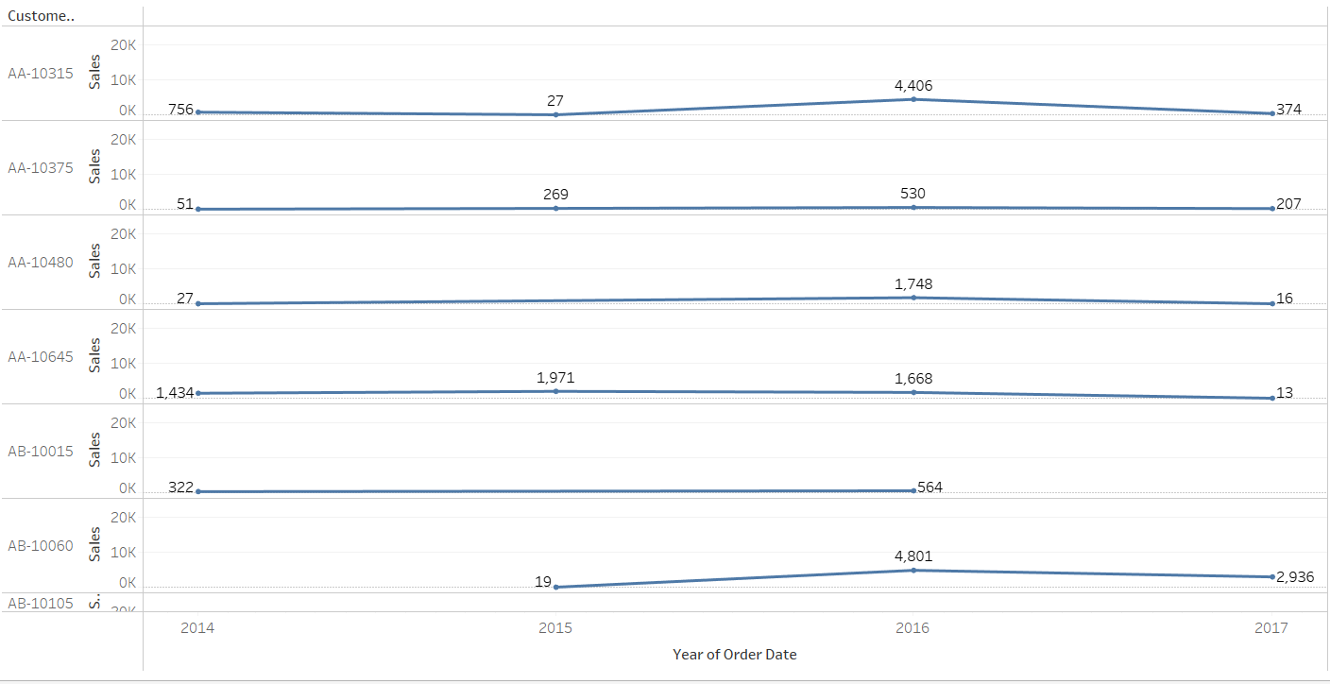

**5.How do sales vary based on different days of the week and product categories?**

Use a grouped bar chart with days of the week as x-axis categories, and bars segmented by product categories. This will show sales distribution across days and categories.

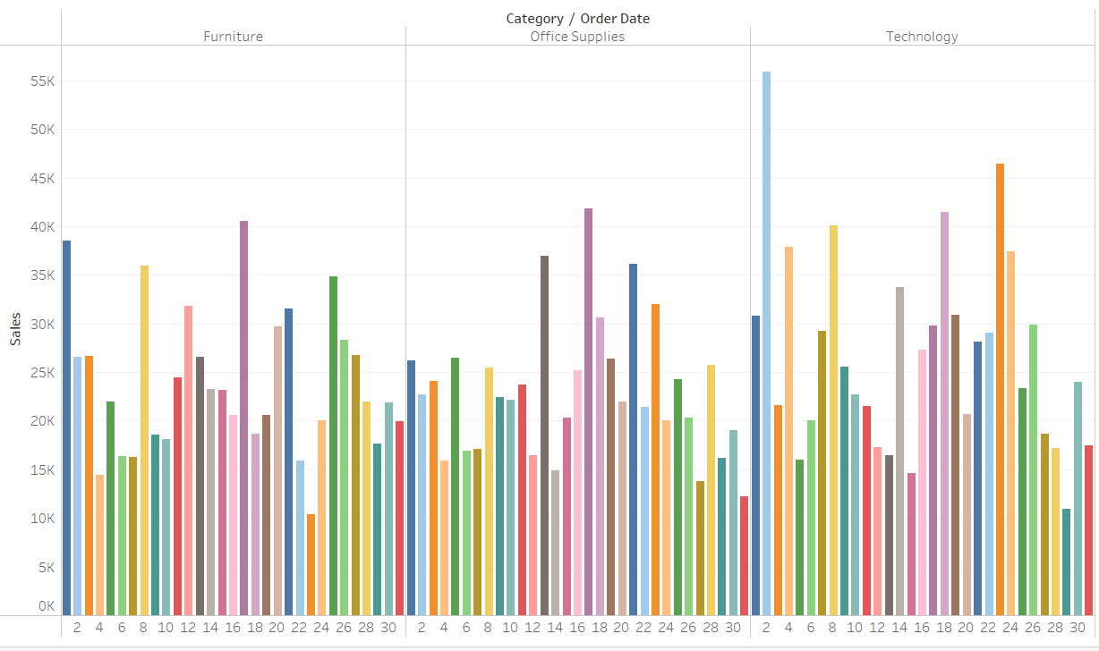

**6.Can we visualize the sales growth of different product categories over time?**

Use a line chart with time on the x-axis and total sales on the y-axis, with separate lines for each product category.

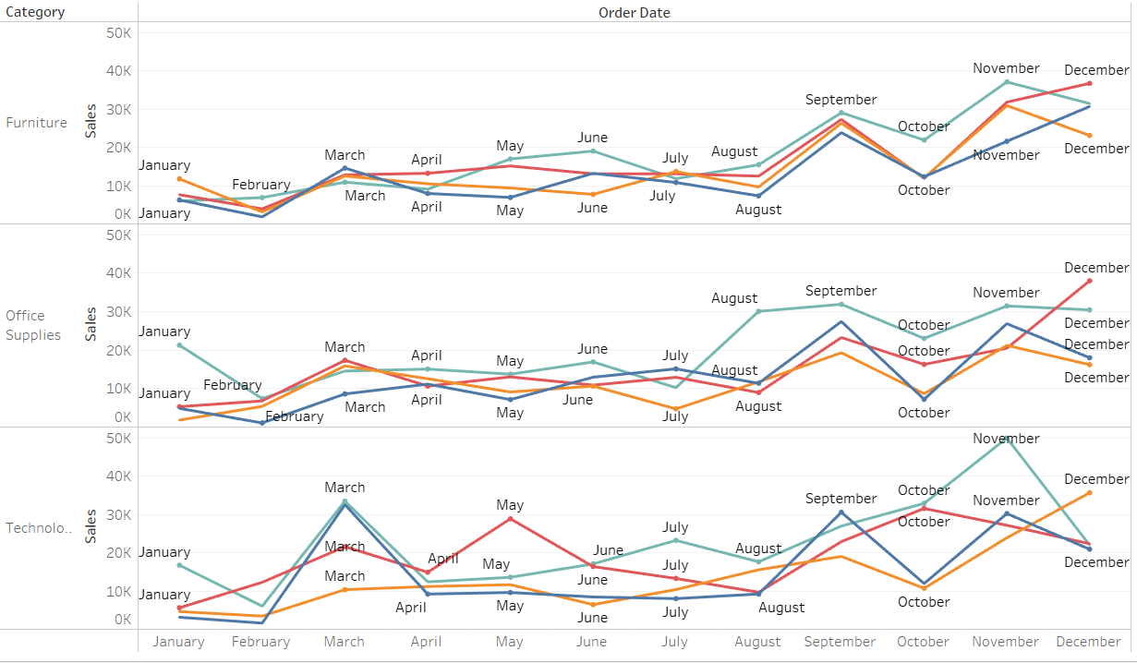

**7.How does the sales distribution vary across different regions in the "Superstore" dataset?**

Use a bar chart with regions on the x-axis and total sales on the y-axis. This will compare sales across different regions.

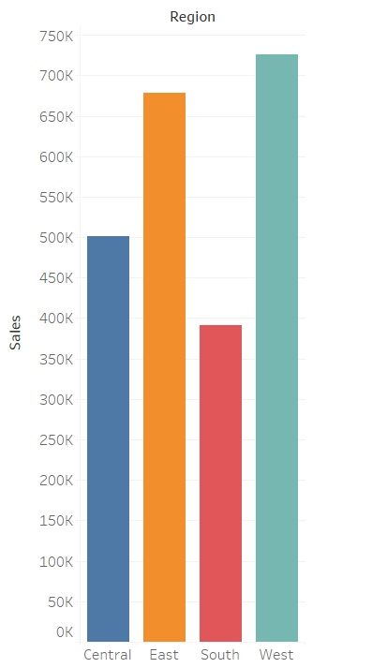

**8.** **Can we visualize the composition of profits across various subcategories within different customer segments?**

Used a stacked bar chart with customer segments on the x-axis and bars segmented by subcategories. This will show how profits are distributed across subcategories within each customer segment.

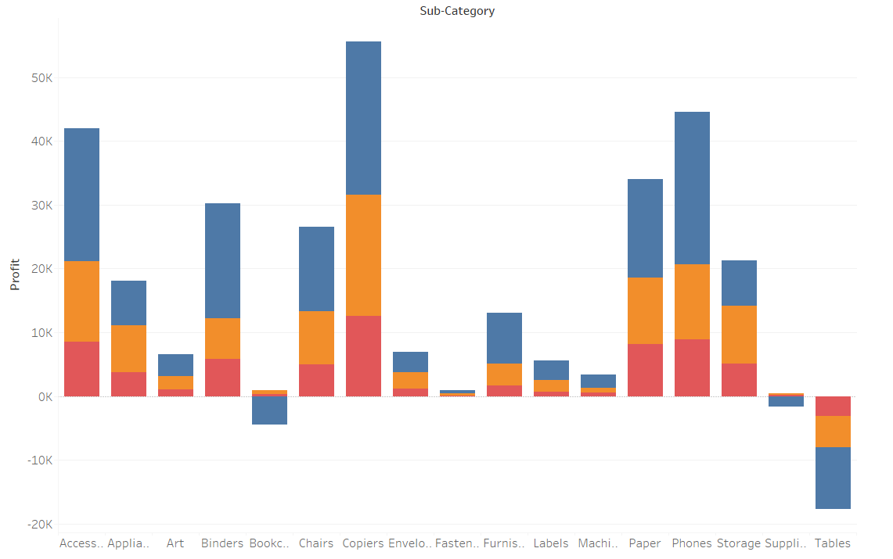

**9.What is the percentage contribution of each region to the overall sales?**

Use a pie chart or a stacked bar chart with regions as segments. This visualization will show the proportion of total sales contributed by each region.

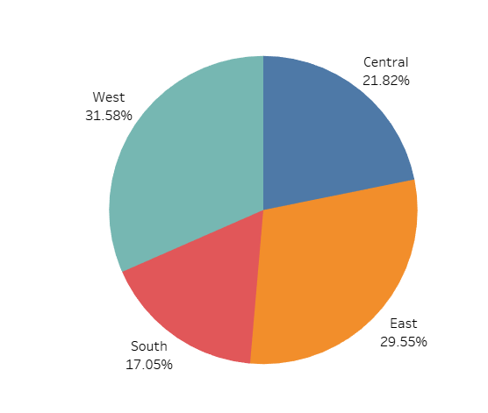

**10.Can we visualize the profit margins associated with different shipping modes and customer segments?**

Use a stacked bar chart with shipping modes and customer segments as x-axis categories, and bars segmented by profit margins. This will compare profit margins across shipping modes and customer segments.

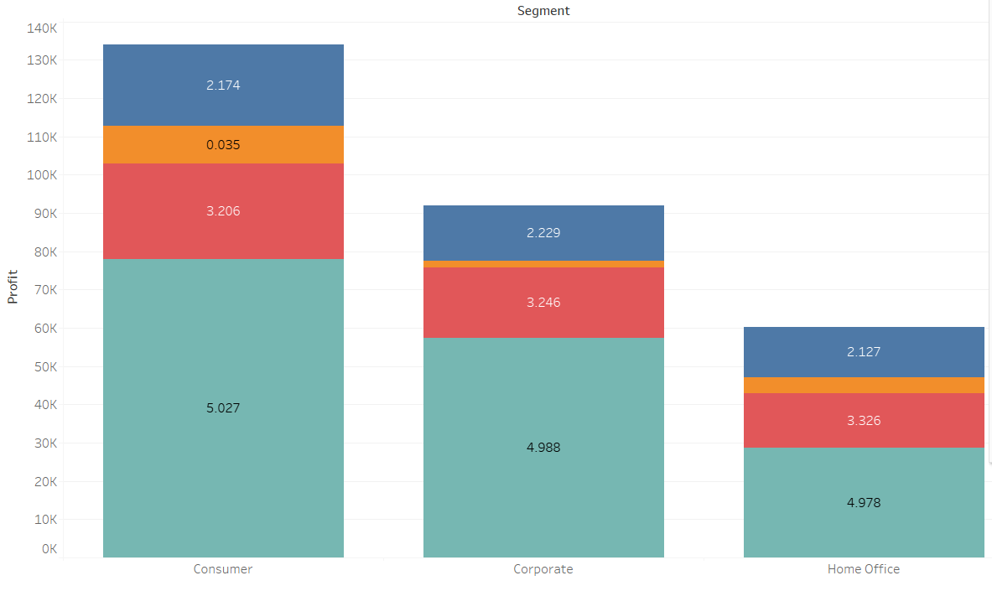

**11.How long does it take to process orders for different product categories?**

Used a bar chart with product categories on the x-axis and average processing time on the y-axis. This will show the average processing time for each product category.

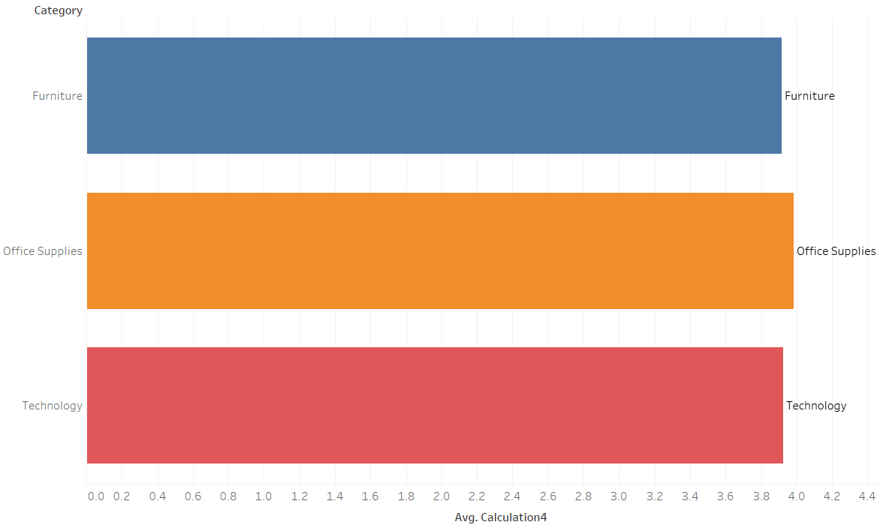

**12. How do discounts affect overall profit?**

Used a scatter plot with discounts and profit on y axis and order date on x axis as it shows a relationship of profit and discount happened on a specific date of order

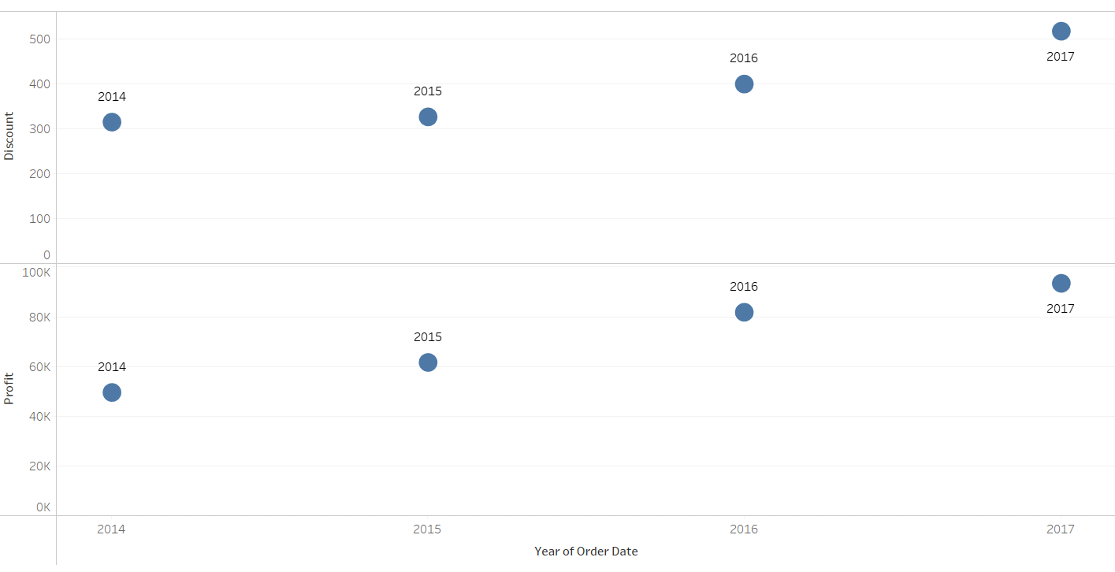

**13. Can we visualize the relationship between product sales and profitability for different product categories?**

Used a line chart with sales and profit on the y-axis and order date on the y-axis. This will show how sales correlate with profitability for different dates.

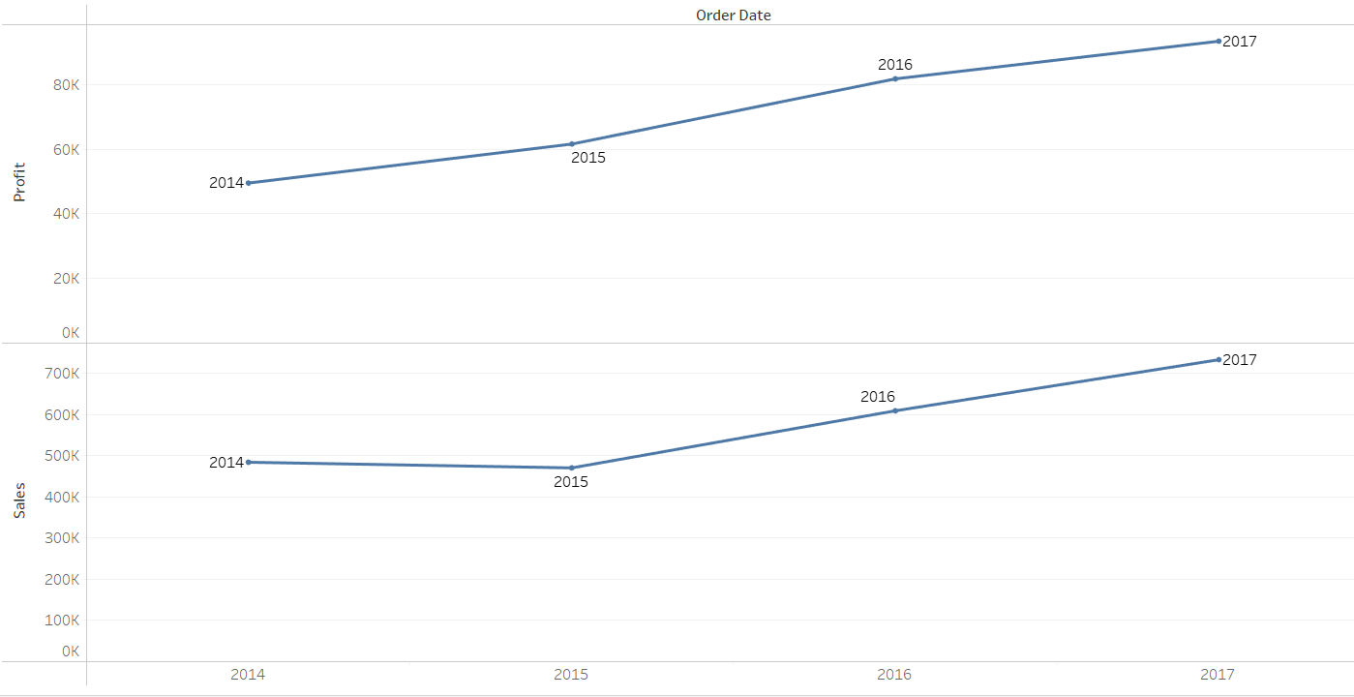

**14. What is the distribution of order quantities for products in the dataset?**

Used a histogram or a bar chart with order quantities on the x-axis and frequency (count of orders) on the y-axis. This will show the distribution of order quantities.

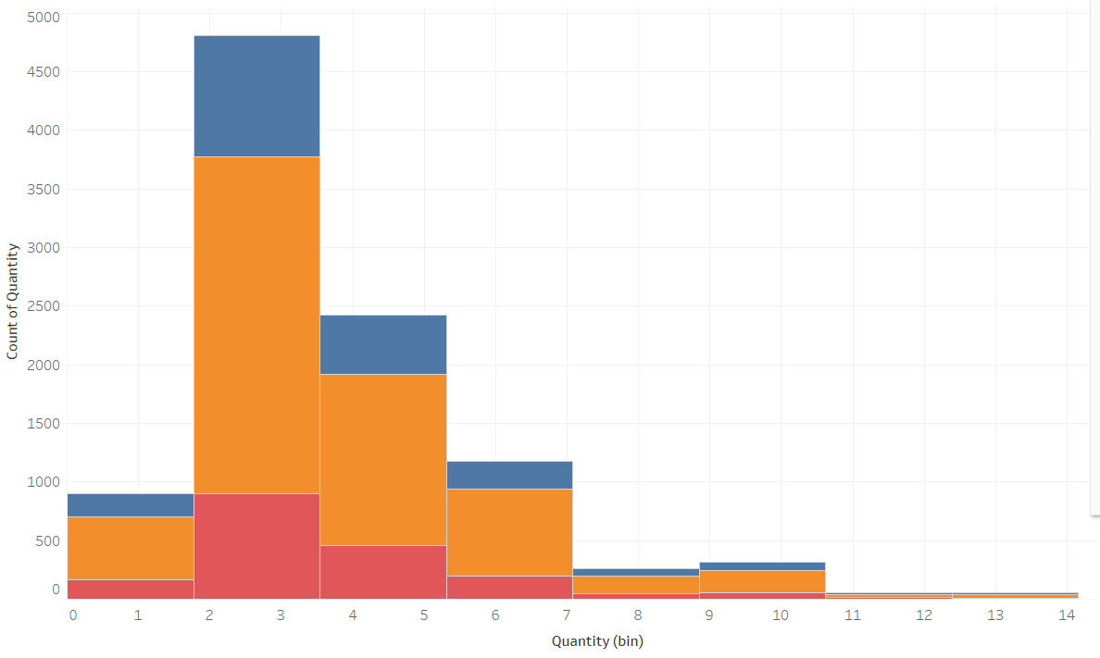

**15.How do the profit distributions vary across different product categories?**

Used a bar chart with product categories on the x-axis and profit on the y-axis. This will show the distribution of profits across different categories.

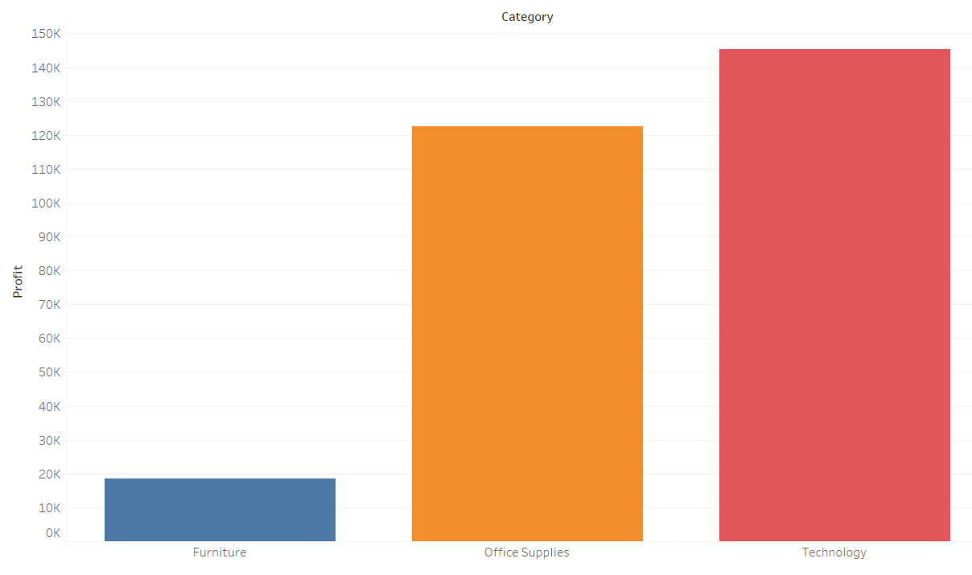

**16. Can we compare the shipping time distributions for different shipping modes?**

Used a bar chart with shipping modes on the x-axis and average shipping time on the y-axis. This will compare the distribution of shipping times across different modes.

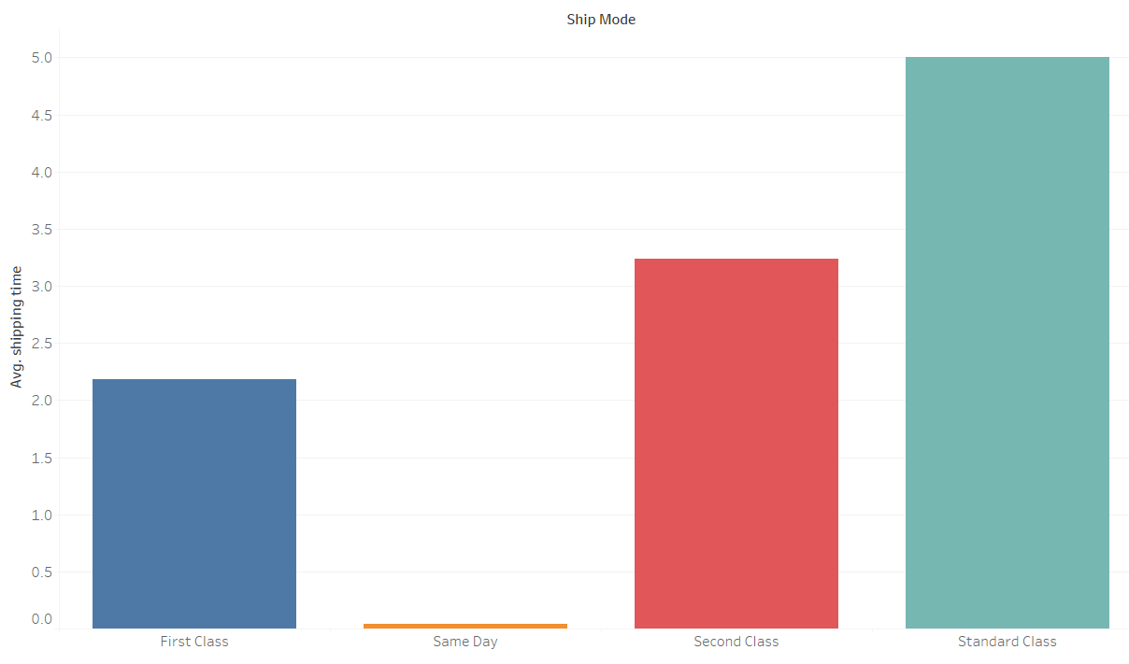

**17. What is the monthly trend in the number of orders shipped?**

Use a line chart with months on the x-axis and total number of orders on the y-axis. This will show how the number of orders shipped changes over time.

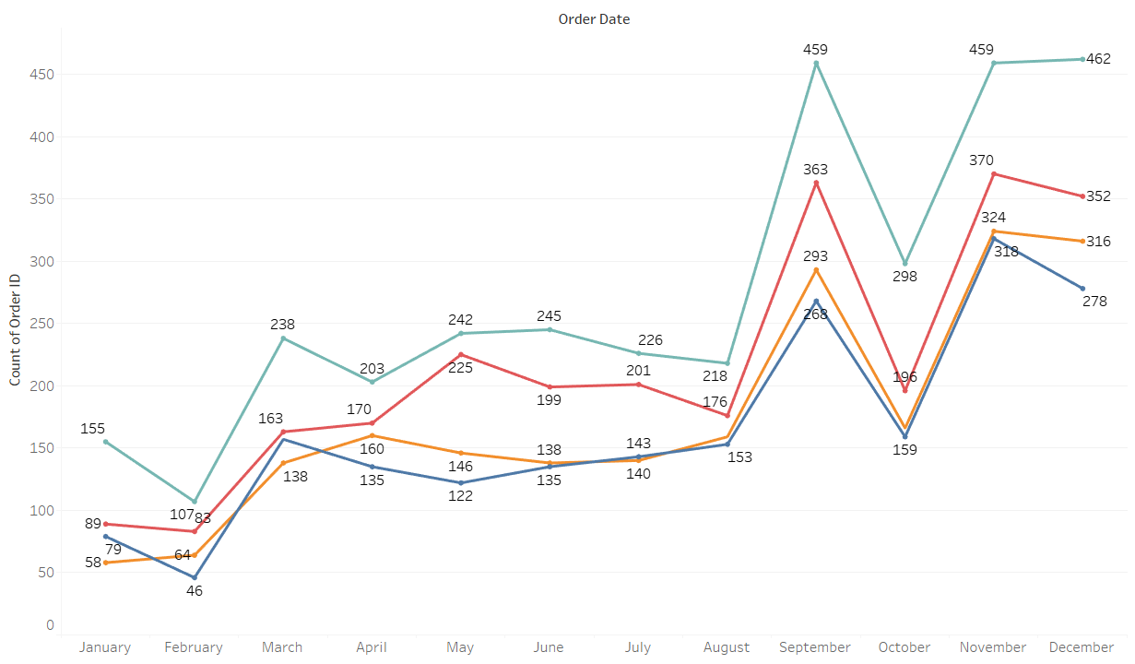

**18. How do different customer segments perform in terms of sales and discount rates?**

Use a grouped bar chart with customer segments on the x-axis and bars segmented by sales and discount rates. This will compare sales and discount rates across customer segments.

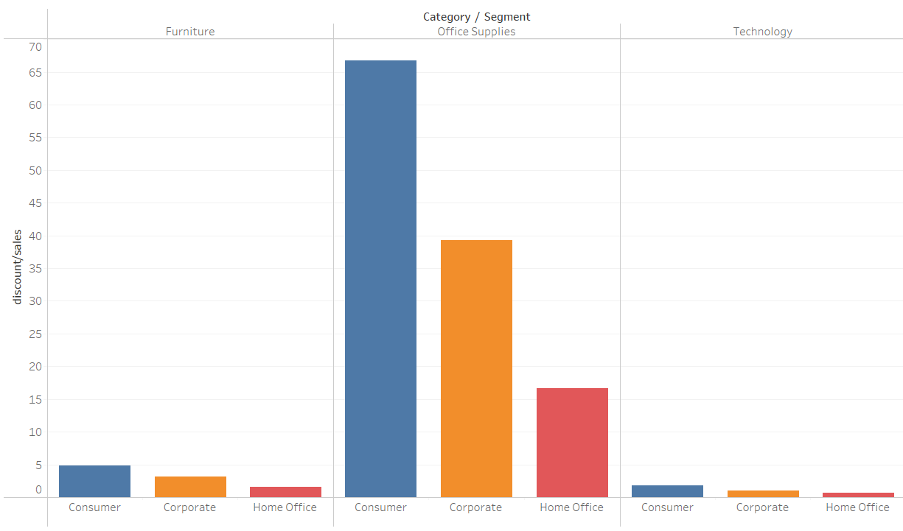

**19. What are the sales and profit trends across different product subcategories and regions in the Superstore dataset?**

Used a bar grouped bar chart to show profit trends across different products where sub categories are in x-axis and profit and sales are in y-axis.

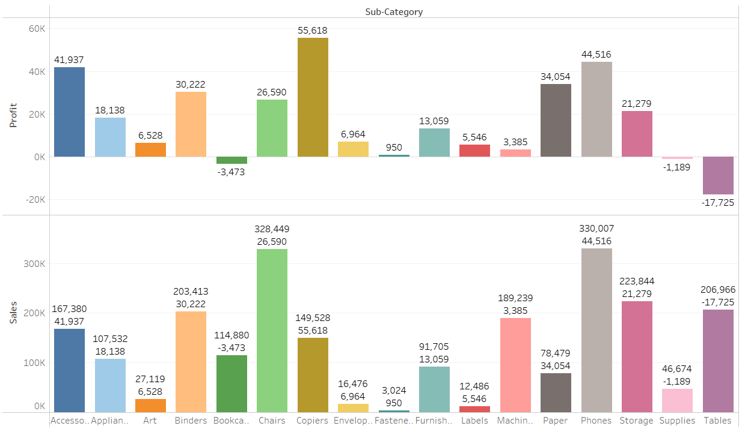

**20. What is the average delivery duration for different regions and ship modes?**

Use a grouped bar chart with regions and ship modes on the x-axis, and average delivery duration on the y-axis. This will compare average delivery durations across regions and ship modes.

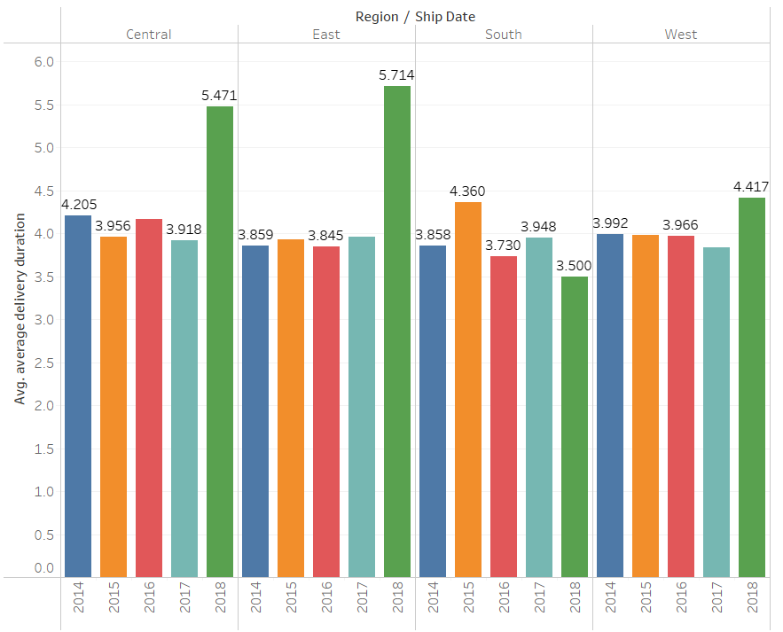

**21.How has the average order quantity changed over the years for various product categories?**

Line chart showing the trend in average order quantity over the years for each product category.

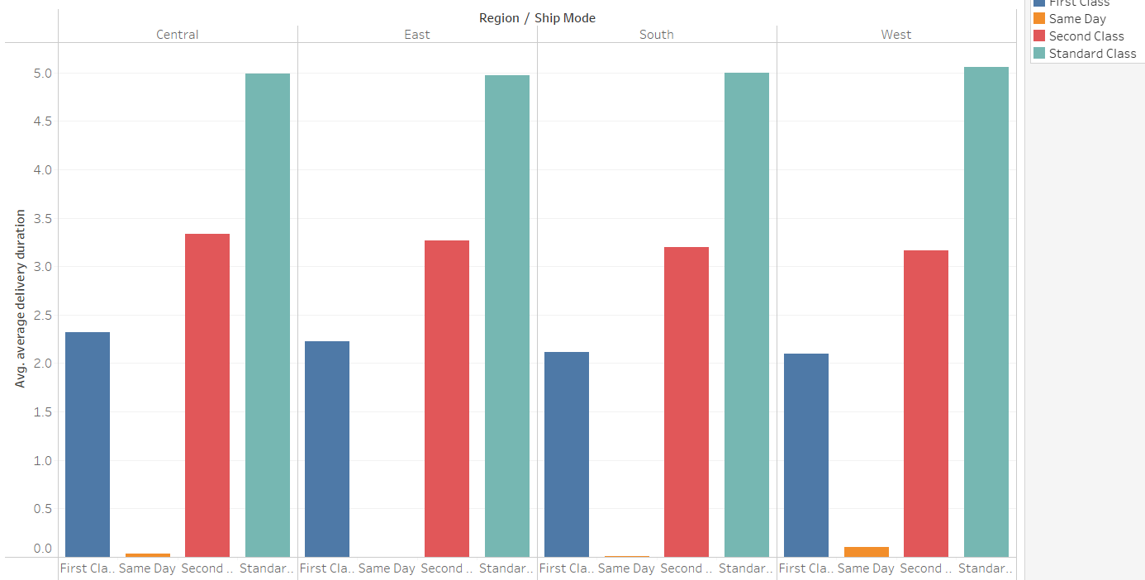

**22. How has the average order quantity changed over the years for various product categories?**

In a heatmap, the discount rates and order quantities are grouped into bins or categories, and the color intensity represents the frequency or density of data points within each bin.

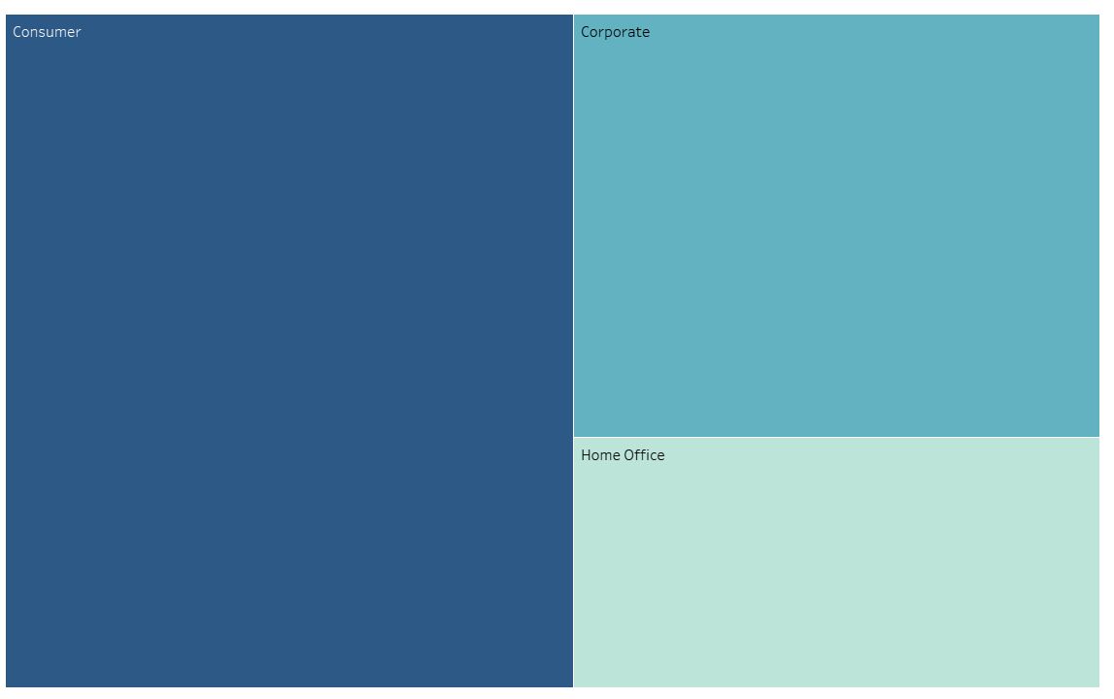

**23. What is the proportion of orders returned in each region within the Superstore dataset?**

Each bar represents a region, and it is divided into segments representing the total number of orders and the number of returned orders within that region.

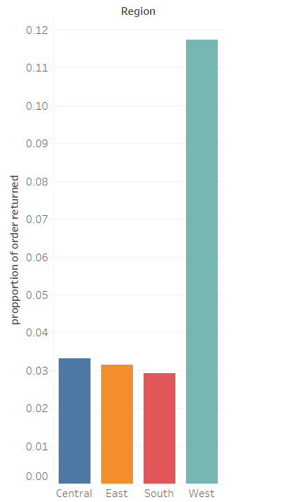

**24. Can you compare the profit of different products for different subcategories?**

In a heatmap, the x-axis represents the product subcategories, the y-axis represents the different products, and the color intensity represents the profit. Each cell in the heatmap represents the profit of a specific product within a subcategory.

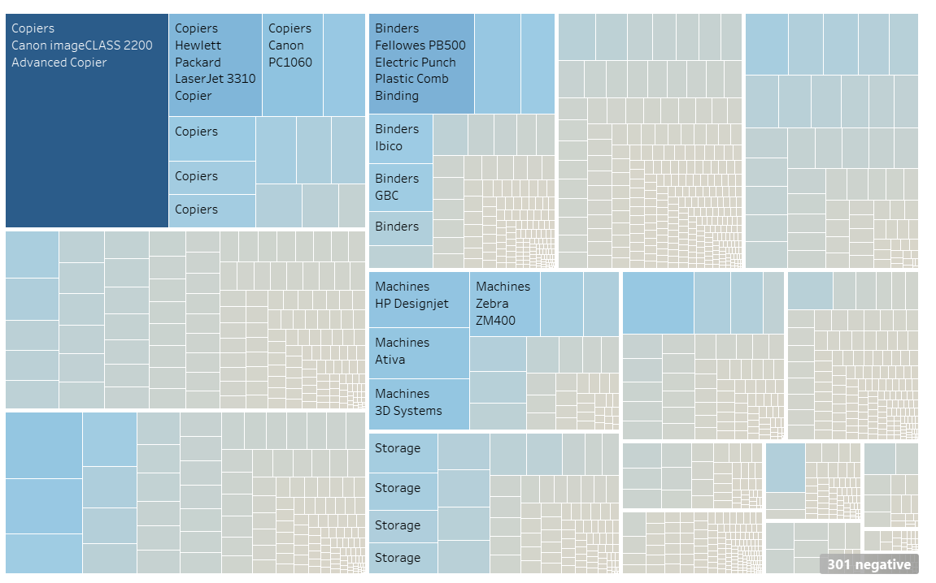

1. **25.** **Which shipping mode is the most commonly used in the Sample Superstore dataset?**

In a pie chart, each slice represents a shipping mode, and the size of each slice corresponds to the proportion of orders using that shipping mode.

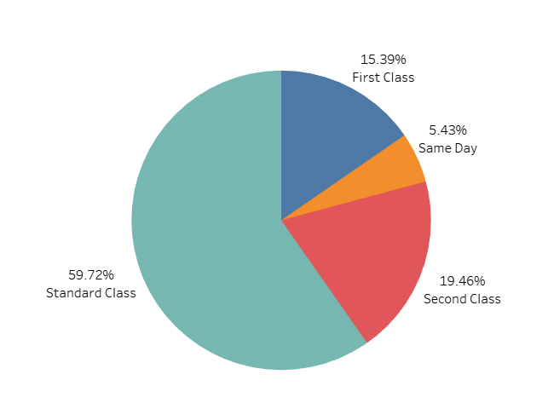

**26.** **How does the sales performance of different regions evolve throughout the quarters of a year?**

In a line chart, each region is represented by a line, and the x-axis represents quarters of the year while the y-axis represents total sales. Each line tracks the sales performance of a specific region over time, allowing for a clear visualization of trends and comparisons between regions.

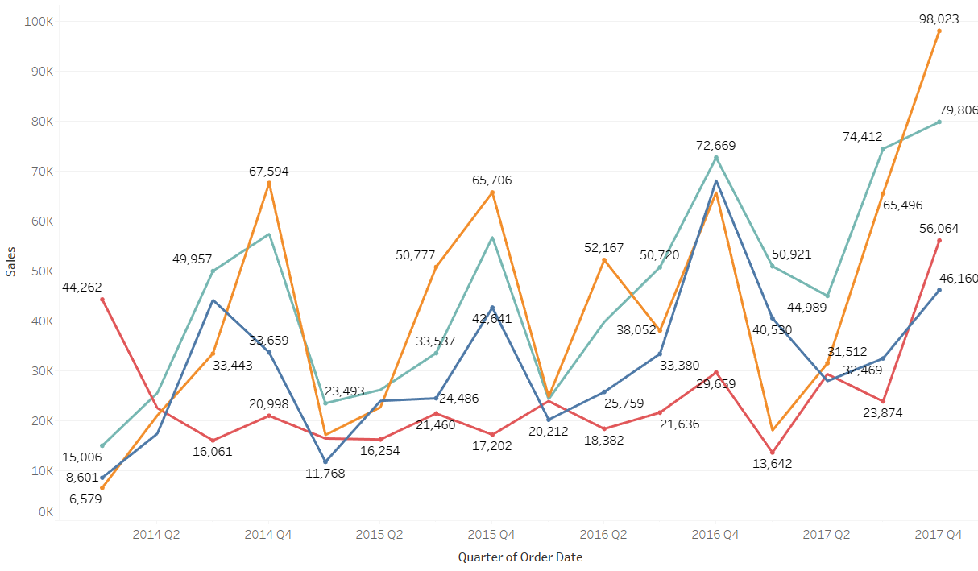

**27.** **What is the distribution of order priorities across different product categories?**

In a grouped bar chart, each product category has multiple bars side by side, with each bar representing a different order priority. The x-axis represents different product categories, and the y-axis represents the total number of orders. This allows for a direct comparison of the number of orders with different priorities within each product category.

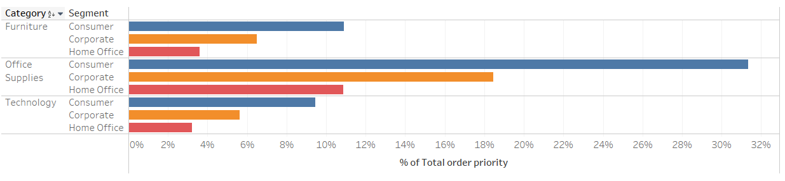

**28. What is the relationship between discounts and sales?**

In a line chart, the x-axis represents the range of discount values, and the y-axis represents the average or total sales for each discount level.

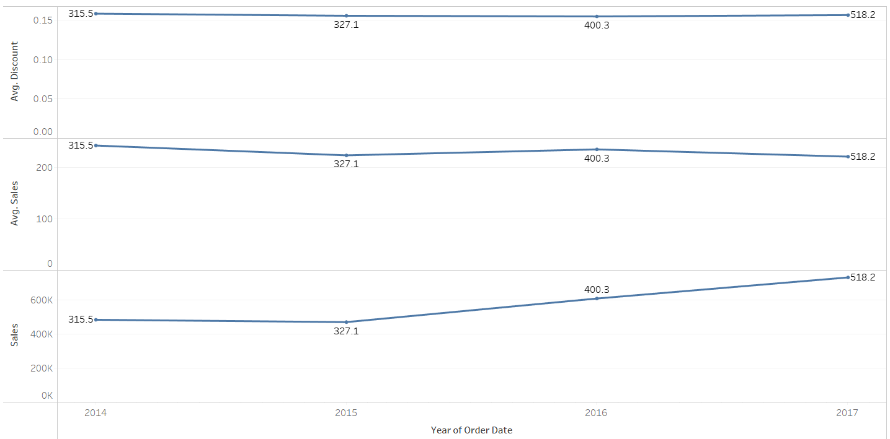

**29. How does the average order value differ between repeat customers and new customers?**

In a grouped bar chart, we'll have two bars side by side representing the average order value for repeat customers and new customers.



**30. What is the geographical distribution of returns and its impact on overall profitability?**

The bar chart shows the profitability of each geographic region, either as total profit or profit margin. Each region has two bars side by side or stacked bars, representing the profitability of orders with and without returns.

